**ICT LAB RECORDS**

**22BT04051 KANDARP SANKET PANDYA** (CSE) **DIV – 1**

# WHY IS ICT INTRODUCED TO US?

ICT is the need to develop with the technology its means to research on the new technology and get to know what can be added updated and removed from the development.Its is necessary to learn this as it brings software and hardware knowledge to us with which we can live with developing world and take initiatives to develop it more upbringing new technologies and resources to the growing science and technology.

# WHAT IS HARDWARE?

Computer hardware is a collective term used to describe any of the physical components of an

analog or digital computer. The term hardware distinguishes the tangible aspects of a computing device from software, which consists of written, machine-readable instructions or programs that tell physical components what to do and when to execute the instructions.

Hardware and software are complementary. A computing device can function efficiently and produce useful output only when both hardware and software work together appropriately.

Computer hardware can be categorized as being either internal or external components.

Generally, internal hardware components are those necessary for the proper functioning of the computer, while external hardware components are attached to the computer to add or enhance functionality.

# WHAT ARE INTERNAL COMPUTER COMPONENTS?

Internal components collectively process or store the instructions delivered by the program or operating system (OS). These include the following:

* Motherboard: This is a printed circuit board that holds the central processing unit (CPU) and other essential internal hardware and functions as the central hub that all other hardware components run through.
* CPU: The CPU is the brain of the computer that processes and executes digital instructions from various programs; its clock speed determines the computer's performance and efficiency in processing data.
* RAM. RAM: -- or dynamic RAM -- is temporary memory storage that makes information immediately accessible to programs; RAM is volatile memory, so stored data is cleared

when the computer powers off.

* Hard drive: Hard disk drives are physical storage devices that store both permanent and temporary data in different formats, including programs, OSes, device files, photos, etc.
* Solid-state drive (SSD): SSDs are solid-state storage devices based on NAND flash memory technology; SSDs are non-volatile, so they can safely store data even when the computer is powered down.
* Optical drive: Optical drives typically reside in an on-device drive bay; they enable the computer to read and interact with nonmagnetic external media, such as compact disc read-only memory or digital video discs.
* Heat sink: This is a passive piece of hardware that draws heat away from components to regulate/reduce their temperature to help ensure they continue to function properly.

Typically, a heat sink is installed directly atop the CPU, which produces the most heat among internal components.

* Graphics processing unit: This chip-based device processes graphical data and often functions as an extension to the main CPU.
* Network interface card (NIC): A NIC is a circuit board or chip that enables the computer to connect to a network; also known as a network adapter or local area network adapter, it typically supports connection to an Ethernet network.

Other computing components, such as USB ports, power supplies, transistors and chips, are also types of internal hardware.

This computer hardware chart below illustrates what typical internal computer hardware components look like.

# WHAT ARE EXTERNAL HARDWARE COMPONENTS?

External hardware components, also called peripheral components, are those items that are often externally connected to the computer to control either input or output functions. These hardware devices are designed to either provide instructions to the software (input) or render results from its execution (output).

Common input hardware components include the following:

* Mouse: A mouse is a hand-held pointing device that moves a cursor around a computer screen and enables interaction with objects on the screen. It may be wired or wireless.
* Keyboard: A keyboard is an input device featuring a standard QWERTY keyset that enables users to input text, numbers or special characters.
* Microphone: A microphone is a device that translates sound waves into electrical signals and supports computer-based audio communications.
* Camera: A camera captures visual images and streams them to the computer or through a computer to a network device
* Touchpad: A touchpad is an input device, external or built into a laptop, used to control the pointer on a display screen. It is typically an alternative to an external mouse.
* USB flash drive: A USB flash drive is an external, removable storage device that uses flash memory and interfaces with a computer through a USB port.
* Memory card: A memory card is a type of portable external storage media, such as a CompactFlash card, used to store media or data files.
* Other input hardware components include joysticks, styluses and scanners.

Examples of output hardware components include the following:

* Monitor: A monitor is an output device similar to a TV screen that displays information, documents or images generated by the computing device.
* Printer: Printers render electronic data from a computer into printed material.
* Speaker: A speaker is an external audio output device that connects to a computer to generate a sound output.
* Headphones, earphones, earbuds. Similar to speakers, these devices provide audio output that's audible only to a single listener.

# WHAT IS SOFTWARE?

Software is a set of instructions, data or programs used to operate computers and execute specific tasks. It is the opposite of hardware, which describes the physical aspects of a computer.

Software is a generic term used to refer to applications, scripts and programs that run on a device. It can be thought of as the variable part of a computer, while hardware is the invariable part.

The two main categories of software are application software and system software. An

application is software that fulfills a specific need or performs tasks. System software is designed to run a computer's hardware and provides a platform for applications to run on top of.

# EXAMPLES AND TYPES OF SOFTWARE:---------

Among the various categories of software, the most common types include the following:

* Application software: The most common type of software, application software is a

computer software package that performs a specific function for a user, or in some cases, for another application. An application can be self-contained, or it can be a group of programs that run the application for the user. Examples of modern applications include office suites, graphics software, databases and database management programs, web browsers, word processors, software development tools, image editors and

communication platforms.

* System software: These software programs are designed to run a computer's application programs and hardware. System software coordinates the activities and functions of the hardware and software. In addition, it controls the operations of the computer hardware and provides an environment or platform for all the other types of software to work in.

The OS is the best example of system software; it manages all the other computer programs. Other examples of system software include the firmware, computer language translators and system utilities.

* Driver software: Also known as device drivers, this software is often considered a type of system software. Device drivers control the devices and peripherals connected to a

computer, enabling them to perform their specific tasks. Every device that is connected to a computer needs at least one device driver to function. Examples include software that

comes with any nonstandard hardware, including special game controllers, as well as the software that enables standard hardware, such as USB storage devices, keyboards, headphones and printers.

* Middleware: The term middleware describes software that mediates between application and system software or between two different kinds of application software. For example, middleware enables Microsoft Windows to talk to Excel and Word. It is also used to send a remote work request from an application in a computer that has one kind of OS, to an

application in a computer with a different OS. It also enables newer applications to work with legacy ones.

* Programming software: Computer programmers use programming software to write code.

Programming software and programming tools enable developers to develop, write, test and debug other software programs. Examples of programming software include

assemblers, compilers, debuggers and interpreters.

# HOW DOES SOFTWARE WORK?

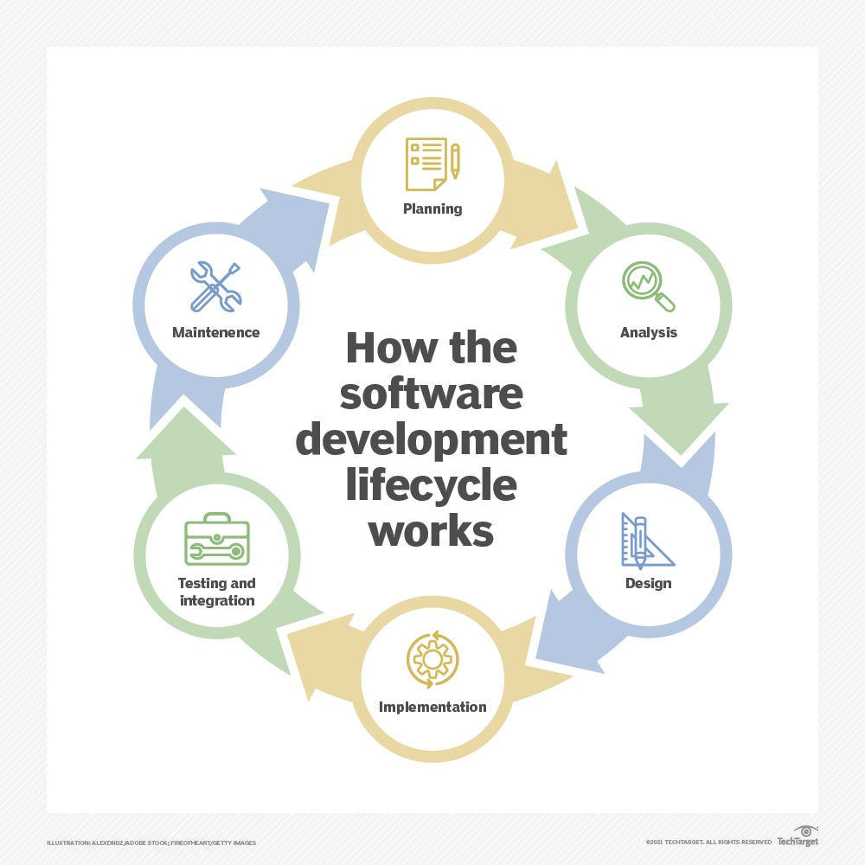All software provides the directions and data computers need to work and meet users' needs. However, the two different types -- application software and system software -- work in distinctly different ways.

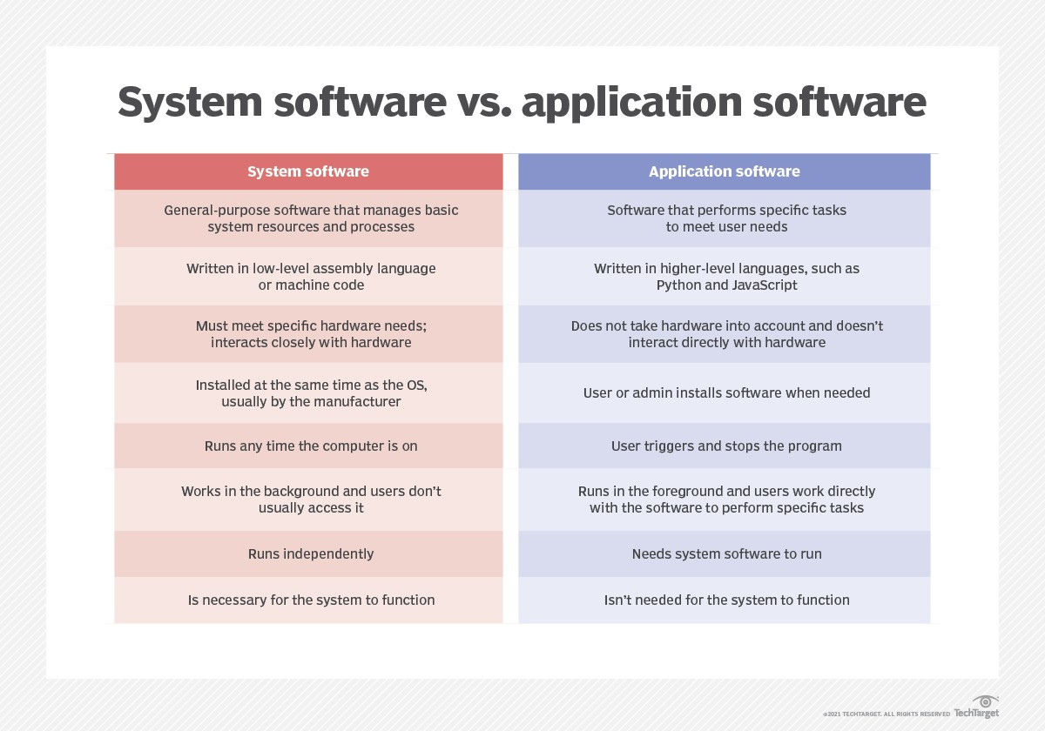

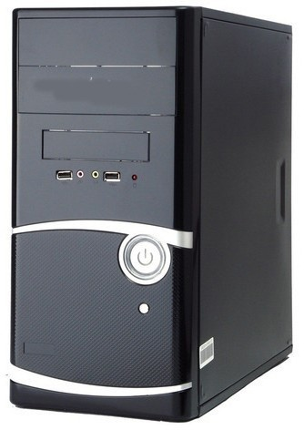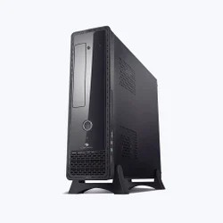

# WHAT DOES COMPUTER CABINET MEAN?

A computer cabinet is an enclosure with fitted, fixed or removable side panels and doors. The cabinet contains a computer rack for mounting computers or other electronic equipment.

# —COMPUTER CABINET ATE AND ATX —

**This is how a cabinet or CPU box looked in the 1980's which used to have a switch to power the computer and also consisted of all other electronic**

**equipment. This had a disadvantage that it made the Computer dependent so when it shuts down many resources were affected and even it had the**

**risk to get corrupted.**

**ATX (Advanced Technology eXtended) is a motherboard and power supply configuration specification developed by Intel in 1995 to improve on**

**previous AT design. It was the first major change in desktop computer**

**enclosure, motherboard and power supply design in many years, improving standardization and interchangeability of parts. The specification defines the dimensions; the mounting points; the I/O panel; and the power and**

**connector interfaces among a computer case, a motherboard, and a power supply.**

# --------------------CPU ---------------------

* **CPU is short for Central Processing Unit. It is also known as a processor or microporcessor.**
* **It's one of the most important pieces of hardware in any digital computing system**
* **Inside a CPU there are thousands of microscopic transistors, which are tiny switches that control the flow of electricity through the integrated circuits.You'll find the**

**CPU located on a computer's motherboard.**

**This is how a CPU looks like —--------------------------------**

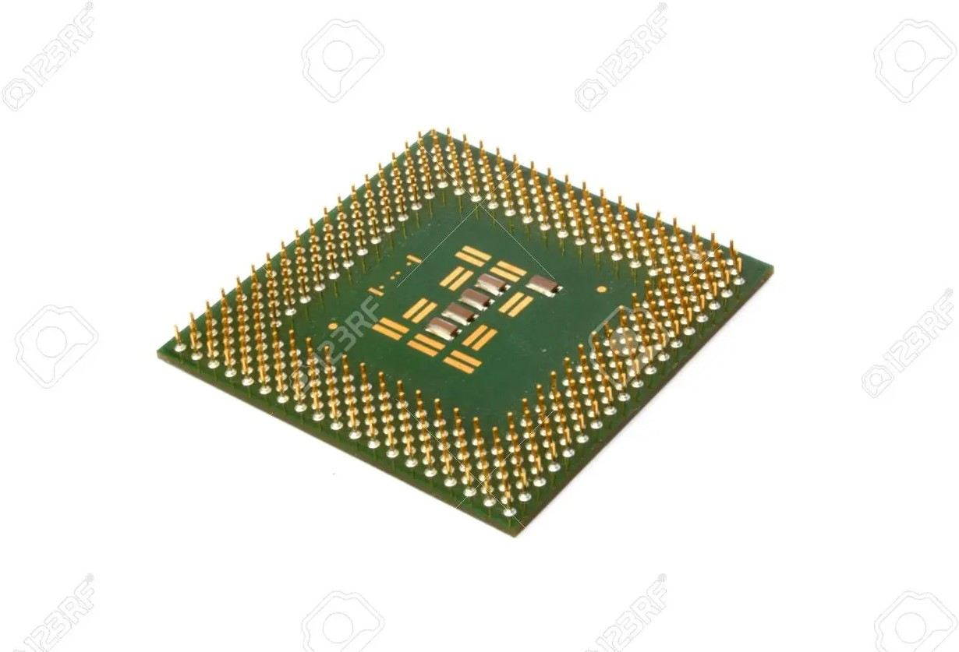

# WHAT DOES A SWITCHED MODE POWER SUPPLY (SMPS) MEANS?

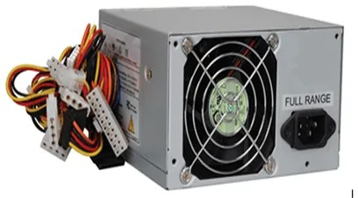A switched-mode power supply (SMPS) is an electronic circuit that converts power using switching devices that are turned on and off at high frequencies, and storage components such as inductors or capacitors to supply power when the switching device is in its non-conduction state.

An SMPS adjusts output voltage and current between different electrical configurations by switching the basics of typically lossless storage such

as capacitors and inductors.

# WHAT IS THE ROLE OF MOTHER BOARD IN THE COMPUTER?

A motherboard is a printed circuit board (PCB) that holds other modular devices, both required and additional, and facilitate communication among the devices to actually have the computer be functional.

Motherboard is like a backbone to a computer system. Components like CPU, RAM, Harddisks along with additional devices like TV Cards, graphics etc. all initially connects to the motherboard. The motherboard enables the devices by ensuring power supply to the device, transferring instruction from and to the device etc.

# WHY IS MOTHERBOARD IMPORTANT?

The motherboard is the backbone that ties the computer’s components together at one spot and allows them to talk to each other. Without it, none of the computer pieces, such as the CPU, GPU, or hard drive, could interact. Total motherboard functionality is necessary for a computer to work well.

# HOW DOES A MOTHERBOARD LOOK LIKE?

The motherboard will look like a piece of flat cardboard or plastic with lots of metal designs and wires on and around it. Parts of a motherboard include power and data connectors, capacitors, heat sinks, and fans. You may also see screw holes for adding new parts or for anchoring it into a device.

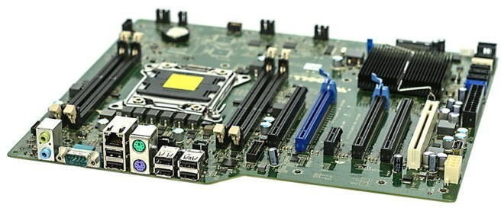

# WHY WE NAME IT AS MOTHERBOARD?

We name this as a motherboard because it carries the main circuit where all the functionalities take place. This is showing “mothership” as a mother carries the load of the home similarly motherboard carries all the activities and devices to function the computer perfectly without any problem, therefore we named it as motherboard .

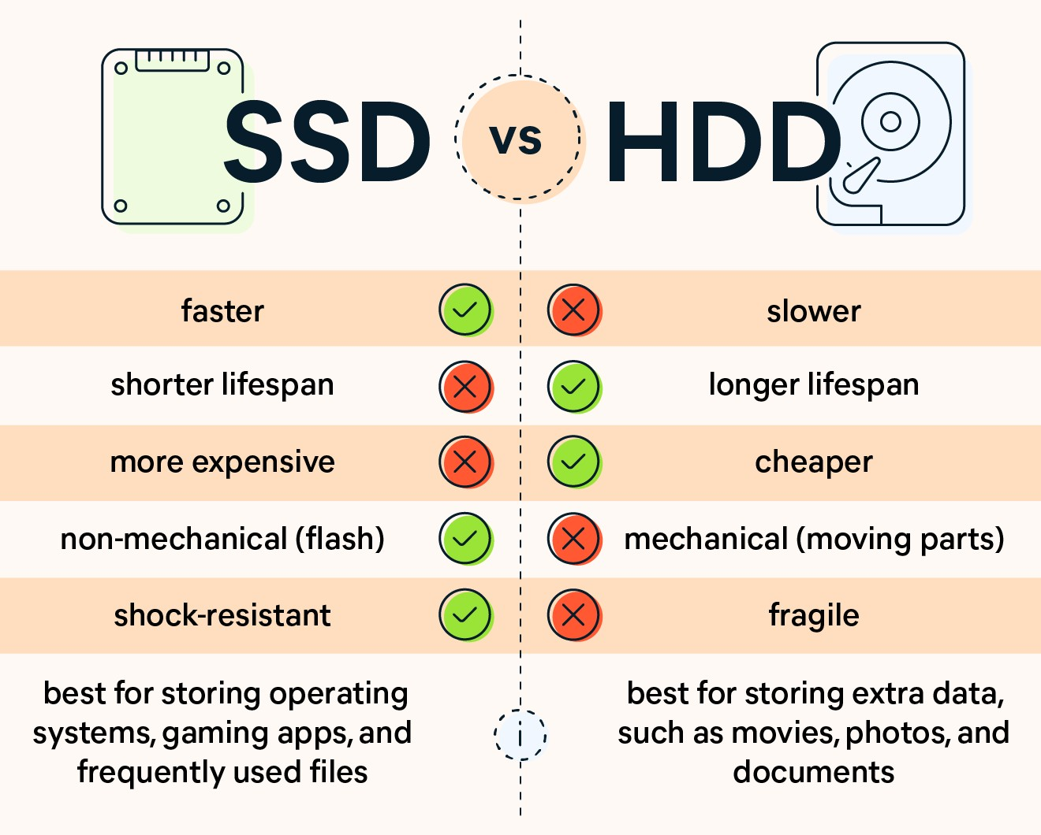

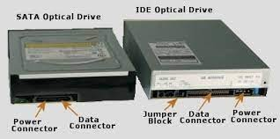

**TYPES OF RAM**

**Type of RAM Year Invented**

FPM-(Fast page mode RAM)- 1990

EDO RAM (Extended data out random access memory) 1994

SDRAM (Single dynamic RAM) 1996

RDRAM (Rambus RAM) 1998

DDR (Double Data Rate) 2000

DDR2 2003

DDR3 2007

DDR4

2012

FPM (Fast page mode RAM)

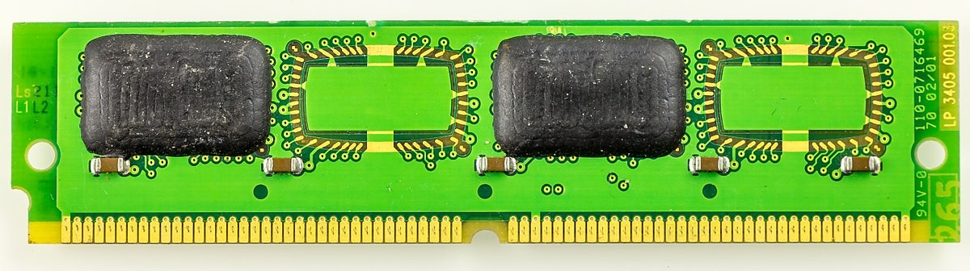

EDO RAM (Extended data out random access memory)

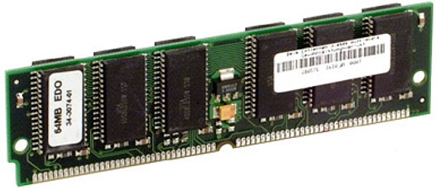

SDRAM (Single dynamic RAM)

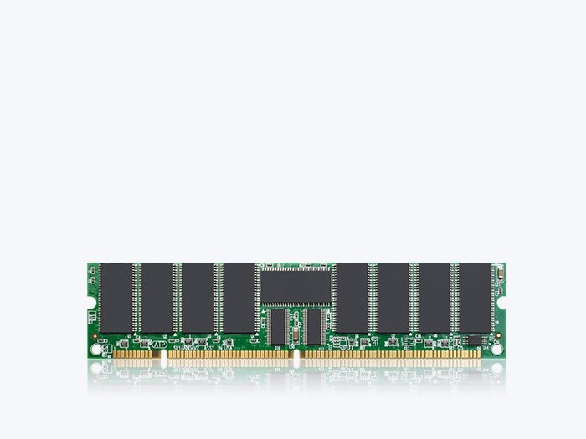

RDRAM (Rambus RAM)

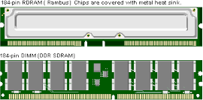

DDR (Double Data Rate)

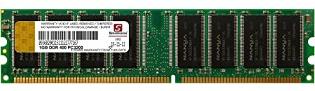

DDR2

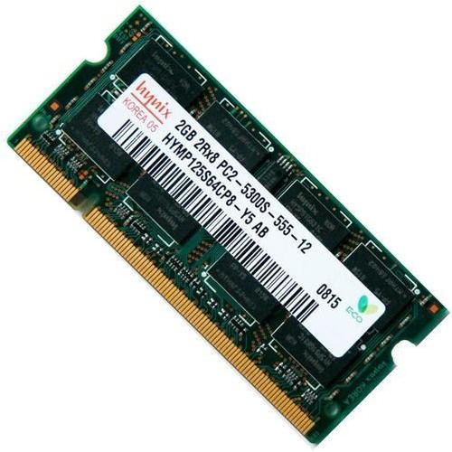

DDR3

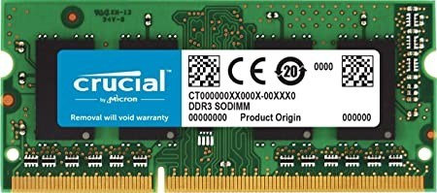

DDR4

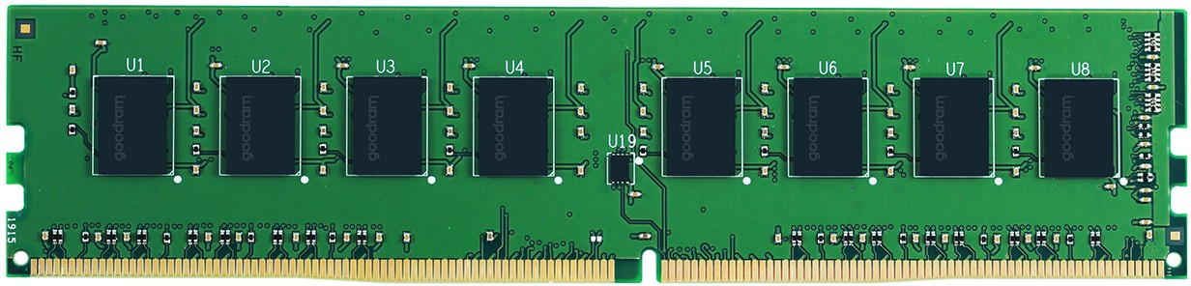

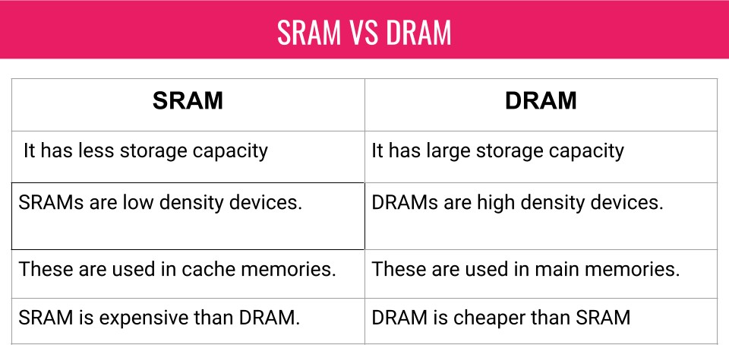

# OLD KEYBOARD:-------

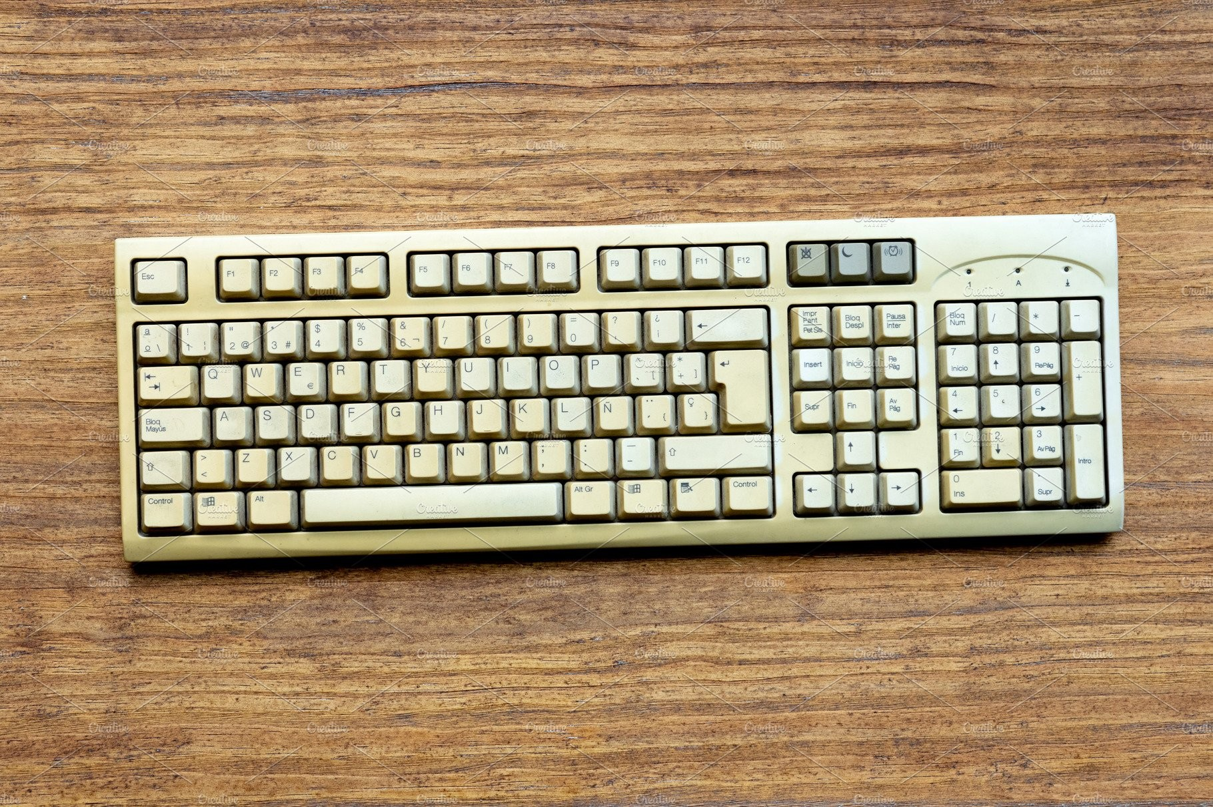**A computer keyboard is a peripheral input device modeled after the typewriter keyboard which uses an arrangement of buttons or keys to act as mechanical levers or electronic switches. Replacing early punched cards and paper tape technology, interaction via teleprinter-style keyboards have been the main input method for computers since the 1970s, supplemented by the computer mouse since the 1980s.**

**Keyboard keys (buttons) typically have a set of characters engraved or printed on them, and each press of a key typically corresponds to a single written symbol. However, producing some symbols may require pressing and holding several keys simultaneously or in sequence. While most keys produce characters (letters, numbers or symbols), other keys (such as the escape key) can prompt the computer to execute system commands. In a modern computer, the interpretation of key presses is generally left to the software: the information sent to the computer, the scan code, tells it only which physical key (or keys) was pressed or released.**

**In normal usage, the keyboard is used as a text entry interface for typing text, numbers, and symbols into application software such as a word processor, web browser or social media app.**

**Touchscreens use virtual keyboards.**

# LATEST KEYBOARD:-------

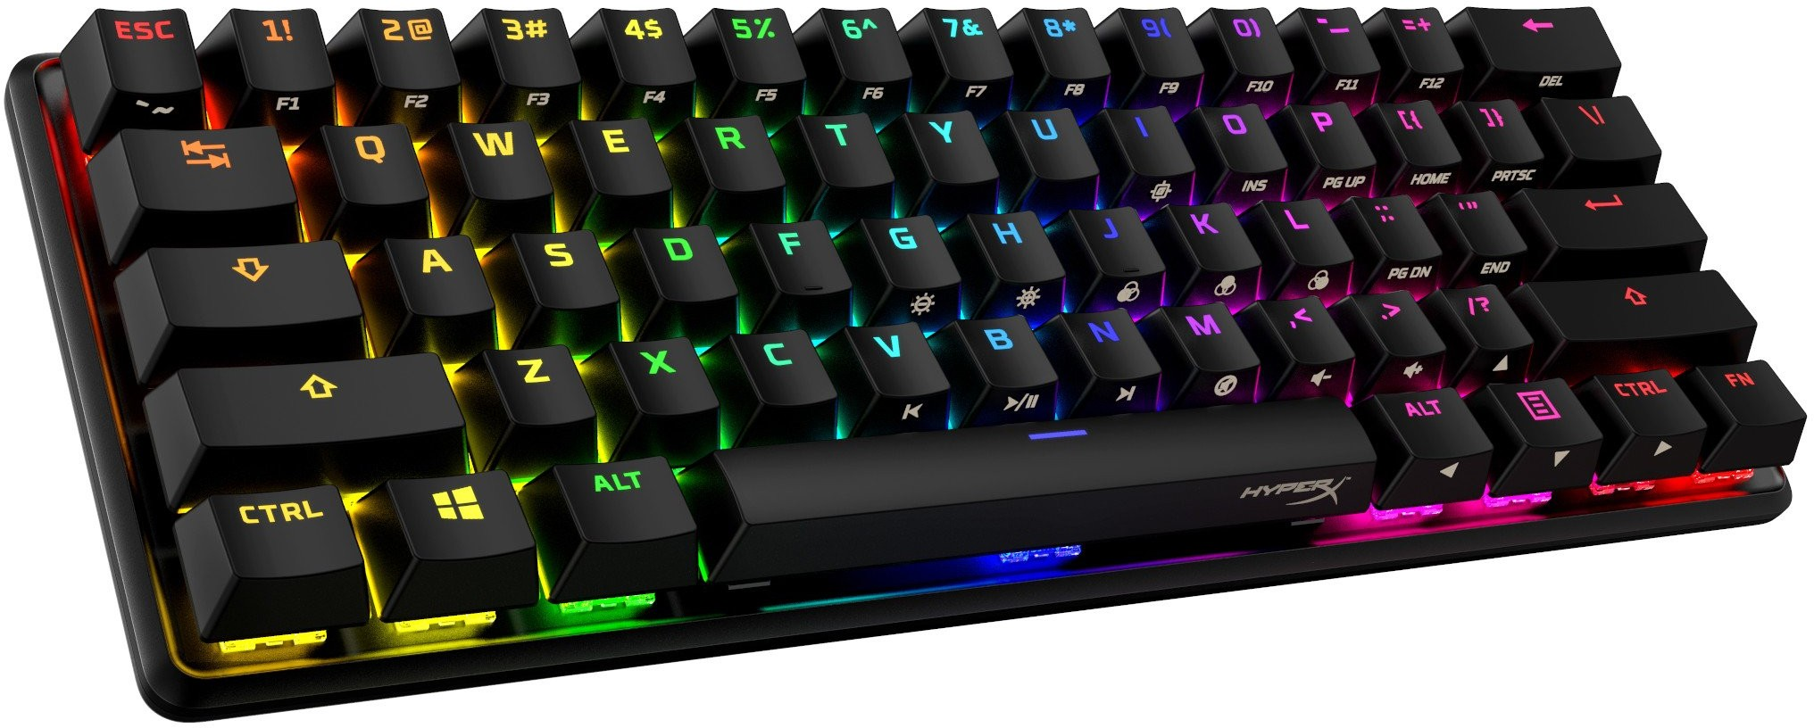**The technology of computer keyboards includes many elements. Among the more important of these is the switch technology that they use.**

**Computer alphanumeric keyboards typically have 80 to 110 durable switches, generally one for each key. The choice of switch technology affects key**

**response (the positive feedback that a key has been pressed) and pre-travel (the distance needed to push the key to enter a character**

**reliably). Virtual keyboards on touch screens have no physical switches and provide audio and haptic feedback instead. Some newer keyboard models use hybrids of various technologies to achieve greater cost savings or better ergonomics. The modern keyboard also includes a control processor and indicator lights to provide feedback to the user (and**

**to the central processor) about what state the keyboard is in. Plug and play technology means that its 'out of the box' layout can be notified to the system, making the keyboard immediately ready to use without need for further configuration unless the user so desires.**

# OLD MOUSE :-------

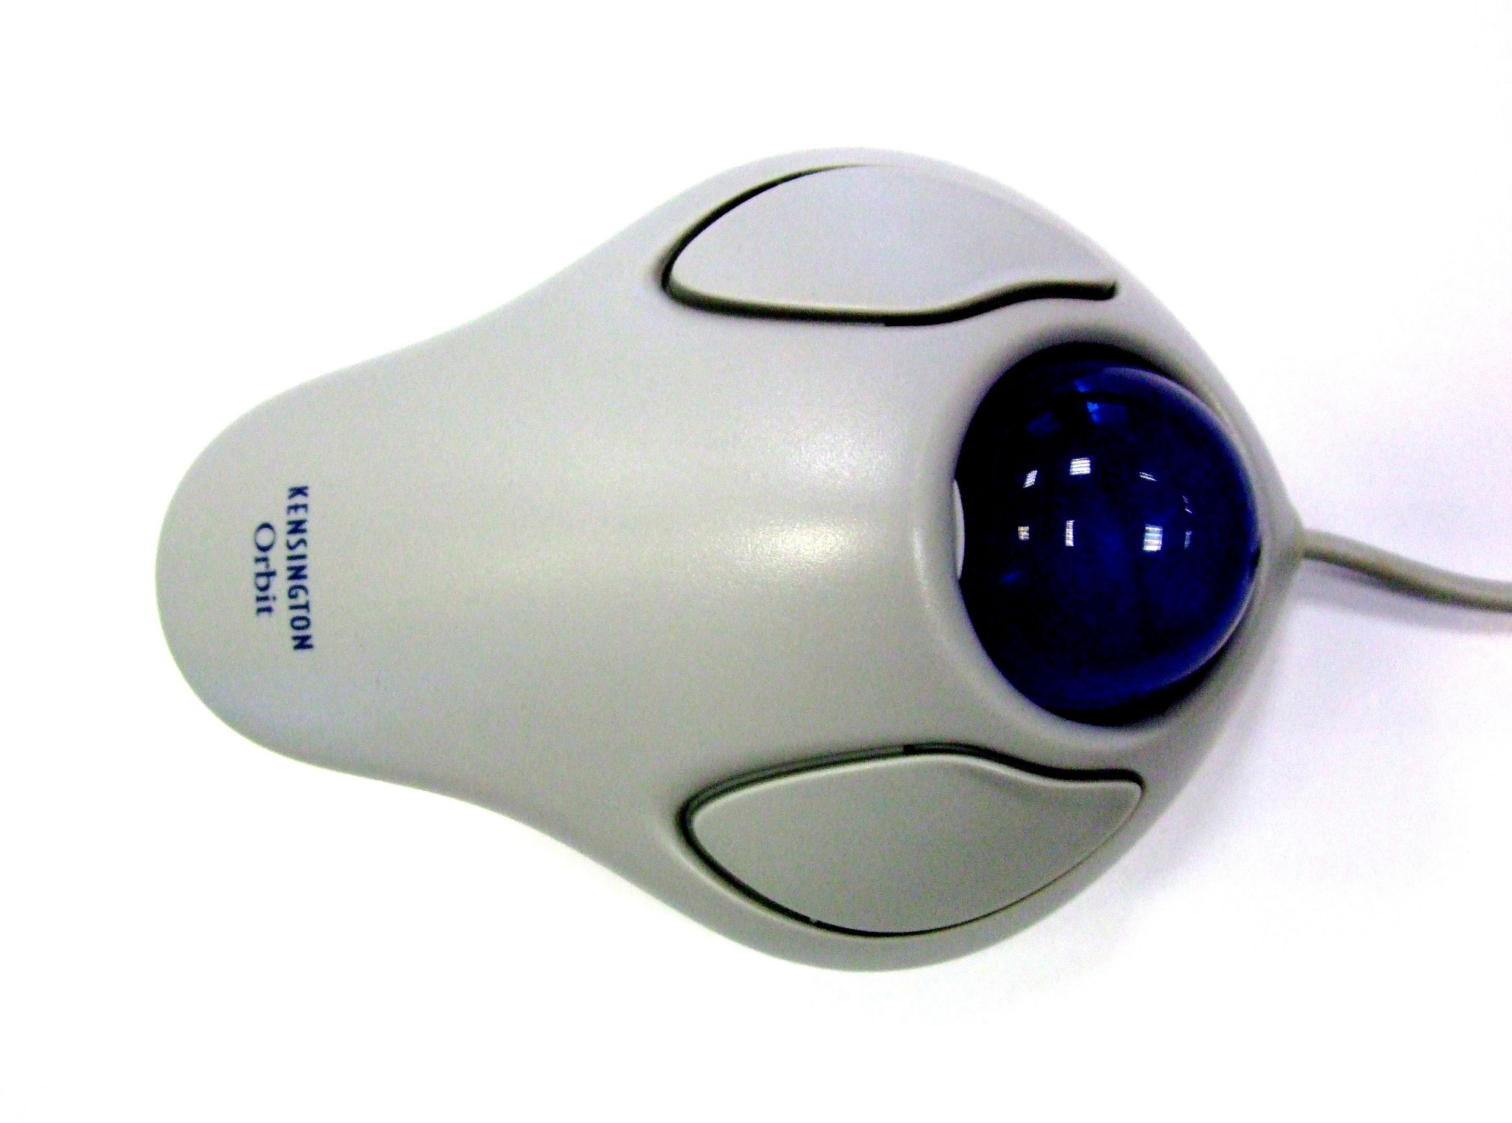**A computer mouse (plural mice, sometimes mouses)[nb 1] is a hand-held pointing device that detects**

**two-dimensional motion relative to a surface. This motion is typically translated into the motion of a pointer on a display, which allows a smooth control of the graphical user interface of a computer.**

**The first public demonstration of a mouse controlling a computer system was in 1968. Mice originally used two**

**separate wheels to track movement across a surface: one in the X-dimension and one in the**

**Y. Later, the standard design shifted to utilize a ball rolling on a surface to detect motion. Most modern mice use optical sensors that have no moving parts. Though originally all mice were connected to a computer by a cable, many modern mice are cordless, relying on short-range radio communication with the connected system.**

**In addition to moving a cursor, computer mice have one or more buttons to allow operations such as the selection of a menu item on a display. Mice often also feature other elements, such as touch surfaces and scroll wheels, which enable additional control and dimensional input**.

# LATEST MOUSE:-------

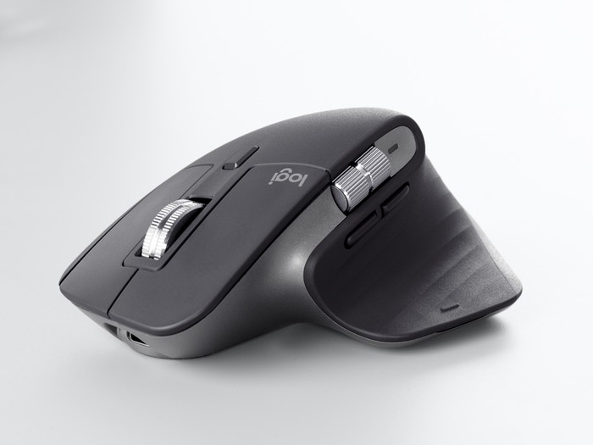**Wired Mouse**

Advantages

-Better accuracy

-Low-latency

-More affordable

-No batteries required

Disadvantages

-Less freedom of movement

-Constrained to length of cord

-Less convenient

**Wireless Mouse**

Advantages

-Extended range from computer

-Not restrained by cord length

-Unrestricted movement

-Doesn’t require mousepad Disadvantages

-Requires batteries to operate

-Lower accuracy (may be negligible for non-gamer users)

-More expensive than wired models

### Bluetooth Mouse

Advantages

* Extended range from computer
* Not restrained by cord length
* Unrestricted movement
* Doesn’t require mousepad Disadvantages
* Requires batteries to operate
* Lower accuracy (may be negligible for non-gamer users)
* More expensive than wired models
* May require purchase of USB Bluetooth receiver if your machine does not have Bluetooth functionality

# WHAT IS PRINTER?

A printer is a hardware output device that is used to generate hard copy and print any document. A document can be of any type such as a text file, image, or the combination of both. It accepts input command by users on a computer or on other devices to print the documents. For example, if you have to submit a project report at your college, you need to create a soft copy of your report and print it with the help of the printer.

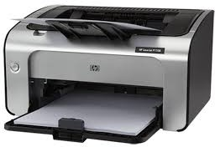

Printers are one of the common computer peripheral devices that can be classified into two

categories that are 2D and 3D printers. The 2D printers are used to print text and graphics on a paper, and 3D printers are used to create three dimensional physical objects.

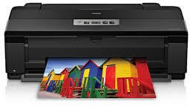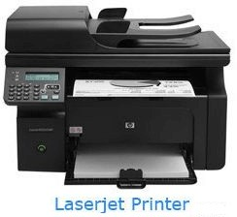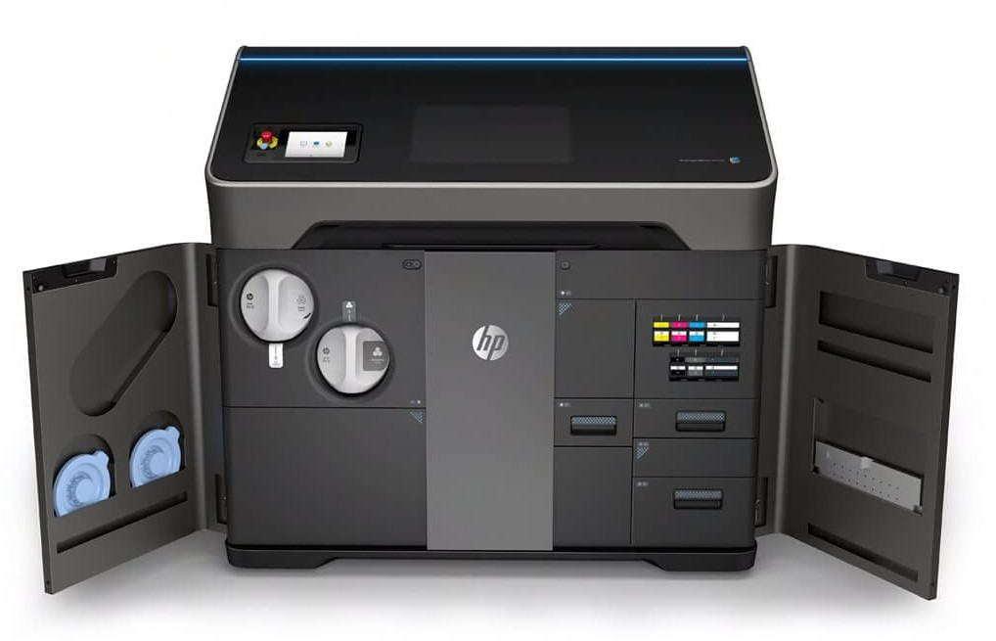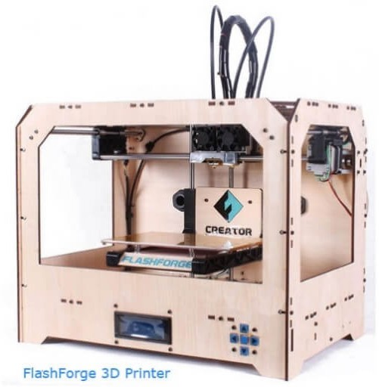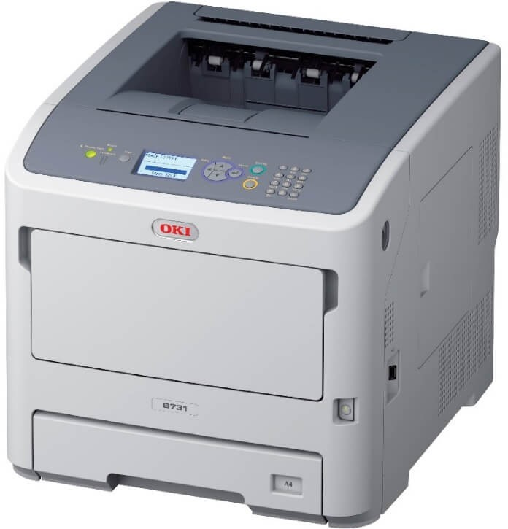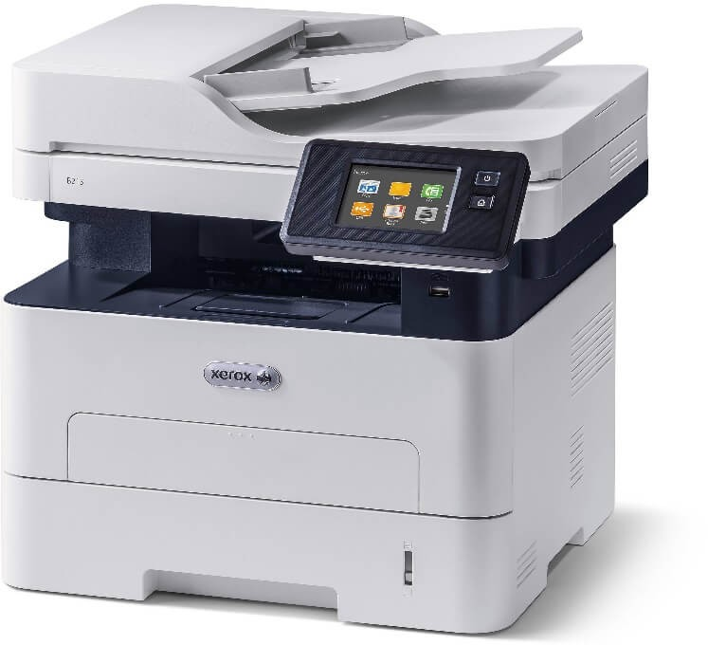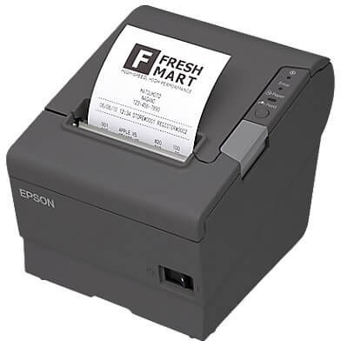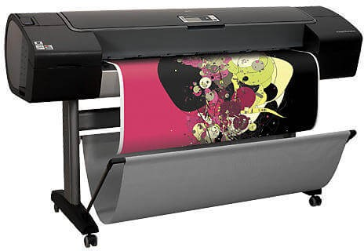

### Types of printer:---

Although there are different types of printers, nowadays, two types of printers are commonly used, which are inkjet and laser printers. A list of all the various types of printers is given below:

* Inkjet Printers
* Laser Printers
* 3D Printers
* LED Printers
* Solid Ink Printers
* Dot Matrix Printers
* Multifunction or All-in-One Printers
* Thermal printer
* Plotter

# WHAT ARE SPEAKERS?

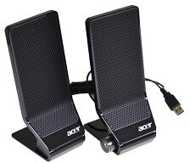Speakers are used to connect to a computer to generate sound, which are one of the most common output devices. Some speakers are designed to connect with any kind of sound system, while some can be hooked up only with computers. With the computer speaker, the computer's sound

card creates a signal that is used to produce sound. The primary objective of speakers is to offer audio output for the listener. The electromagnetic waves are converted into sound waves through the speaker as they are transducers. The devices, like an audio receiver or computer, give audio

input to speakers, which may be in the form of analog or digital. The function of the analog speaker is simply to magnify the analog electromagnetic waves into sound waves.

# Rating a speaker

Speakers are rated in distortion, watts, frequency response, and total harmonic.

* Frequency response: It is produced by speakers, which is the rate of the lows and highs of the sound.
* Watts: For the speakers, it is the amount of amplification.

Total harmonic distortion (THD): It is the amount of distortion created with the help of amplifying the signal.

## NEED OF COMPUTER SPEAKERS

There are many tasks or events that can be completed through speakers. They are used to produce sound to be heard by the listener, create surround sound, add more bass with a subwoofer. External speakers are also available in the market that need to attach to the computer or another device to produce the sound. The external speakers are not needed if you do not need louder sounds, louder sounds, more bass, or you have a smartphone, laptop, or other devices that have internal speakers.

## CATEGORIZATION OF SPEAKERS

Speakers are classified on the basis of the drives that they have and other components that made them unique from others. There are numerous types of speakers available in the market, which are given below with their more technical terms. However, it can be more difficult to define the actual types of speakers directly; therefore, below is given a brief overview of the categorization of speaker types first.

* Dynamic: These types come under the passive speakers, which have one or more woofer drivers. This one is the most common type that contains one or more tweeter drivers and is also well-known for producing low-frequency sound.
* Subwoofer: This type is responsible for producing low-frequency sound as it includes a bass port. They have a large woofer driver. Without necessarily compromising the quality of sound, they have the potential to improve base from other supplementary speakers.
* Horn: These are much similar to dynamic speakers, which includes the way of arranging the drivers in a wave guide structure. As compared to high degree of sensitivity and transmission of sound in large areas, these speakers are with the horn that offers users the benefit to get more enjoy.
* Electrostatic: If you are looking for crisp and detailed sound, it can be the best choice for you. These contain a fine membrane and one drive placed over two conductive panels. These diaphragm speakers, in most cases, are used for high frequencies and always plugged in an outside power outlet. Also, if you are looking for low-frequency speaker types, they are not ideal for this purpose.
* Planar-magnetic: Planar-magnetic speakers have a thin metal ribbon rather than the diaphragms. It is different from electrostatic as there is no requirement for an outside power source to operate them. Furthermore, these speakers can last for a long time and provide high utility value.

# WHAT IS A PEN DRIVE?

A pen drive is a portable Universal Serial Bus (USB) flash memory device for storing and transferring audio, video, and data files from a computer. As long as the desktop or laptop has a USB port, and the pen drive is compatible with the operating system, it should be easy to move the data from the hard drive to the device — and to another computer — in a matter of minutes. The drive gets its name from the fact that many have a retractable port connector like a ballpoint pen, and they are small enough to fit into a pocket. Other names include flash drive, jump drive, and thumb drive.

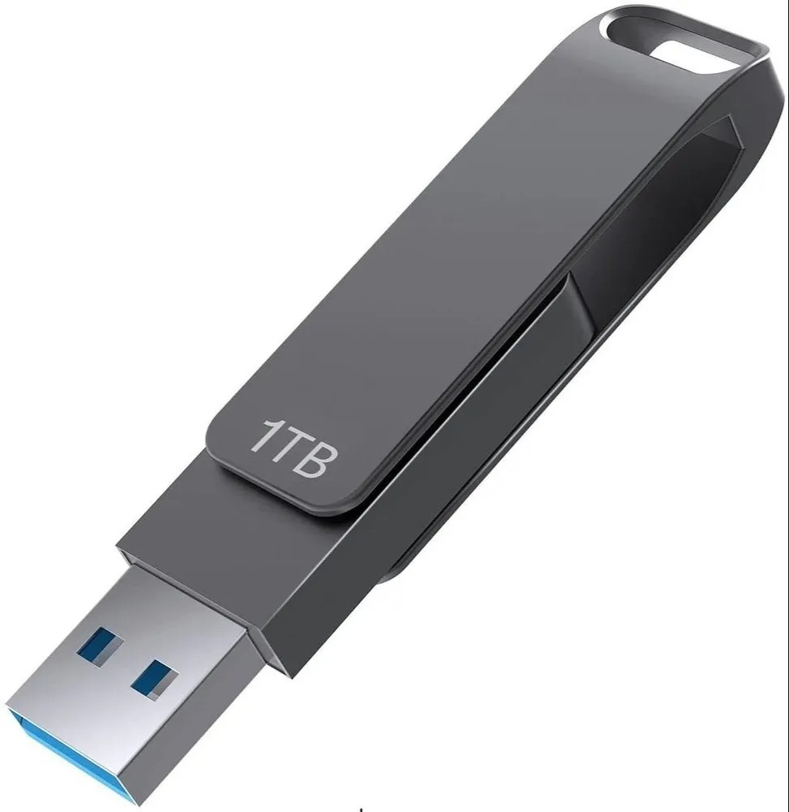

# WHAT IS A OTG PEN DRIVE?

USB On-The-Go (USB OTG or just OTG) is a specification first used in late 2001 that allows USB devices, such as tablets or smartphones, to act as a host, allowing other USB devices, such as USB flash drives, digital cameras, mouse or keyboards, to be attached to them. Use of USB OTG allows those devices to switch back and forth between the roles of host and device. A mobile phone may read from removable media as the host device, but present itself as a USB Mass Storage Device when connected to a host computer.

USB OTG introduces the concept of a device performing both Host and Peripheral roles –

whenever two USB devices are connected and one of them is a USB OTG device, they establish a communication link. The device controlling the link is called the Host, while the other is called the Peripheral.

USB OTG defines two roles for devices: OTG A-device and OTG B-device, specifying which side supplies power to the link, and which initially is the host. The OTG A-device is a power supplier, and an OTG B-device is a power consumer. In the default link configuration, the

A-device acts as a USB host with the B-device acting as a USB peripheral. The host and peripheral modes may be exchanged later by using Host Negotiation Protocol (HNP).

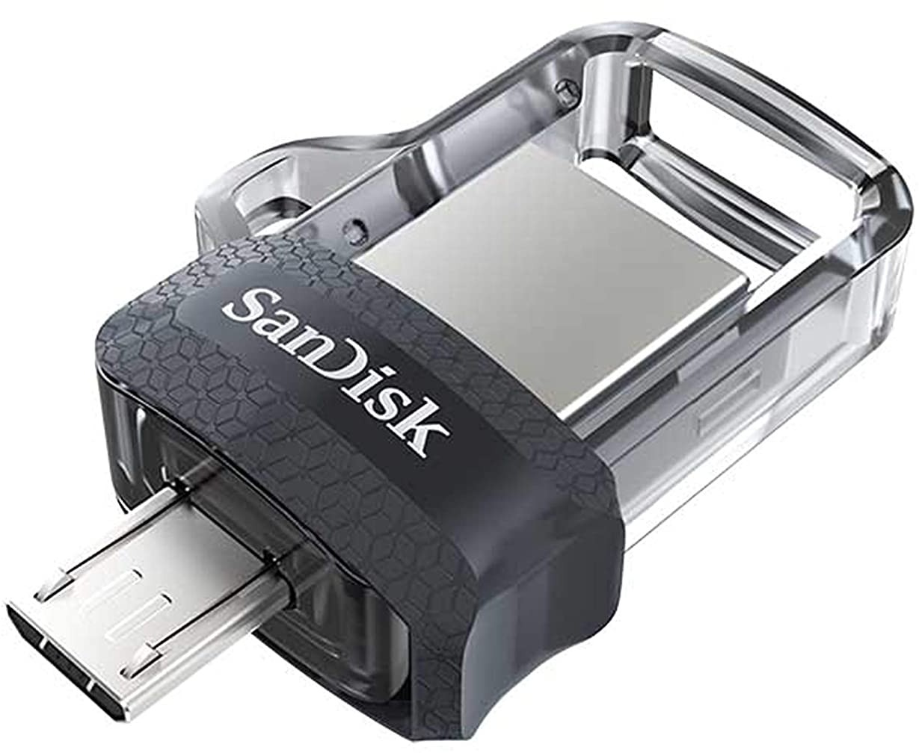

# WHAT IS A PASSWORD PROTECTED PEN DRIVE?

USB Drives or pen drives are cheap and portable tools to secure digital files. We usually store

essential things on our USB drives, like important documents, backup files, etc. USB drives were great for people who work on multiple computers in a day.

Since we store important data on our USB drive, it’s best to secure a USB stick with a password.

Windows 10 offers a BitLocker utility to password-protect drives. However, BitLocker is a bit complicated to use.

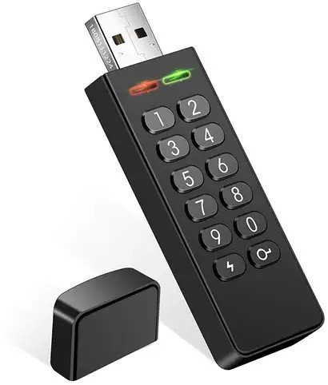

# WHAT IS OPERATING SYSTEM?

An operating system (OS) is the program that, after being initially loaded into the computer by a boot program, manages all of the other application programs in a computer. The application programs make use of the operating system by making requests for services through a defined

application program interface (API). In addition, users can interact directly with the operating

system through a user interface, such as a command-line interface (CLI) or a graphical UI (GUI).

# WHY USE AN OPERATING SYSTEM?

An operating system brings powerful benefits to computer software and software development. Without an operating system, every application would need to include its own UI, as well as the comprehensive code needed to handle all low-level functionality of the underlying computer,

such as disk storage, network interfaces and so on. Considering the vast array of underlying hardware available, this would vastly bloat the size of every application and make software development impractical.

Instead, many common tasks, such as sending a network packet or displaying text on a standard output device, such as a display, can be offloaded to system software that serves as an intermediary between the applications and the hardware. The system software provides a

consistent and repeatable way for applications to interact with the hardware without the applications needing to know any details about the hardware.

As long as each application accesses the same resources and services in the same way, that

system software -- the operating system -- can service almost any number of applications. This vastly reduces the amount of time and coding required to develop and debug an application,

while ensuring that users can control, configure and manage the system hardware through a common and well-understood

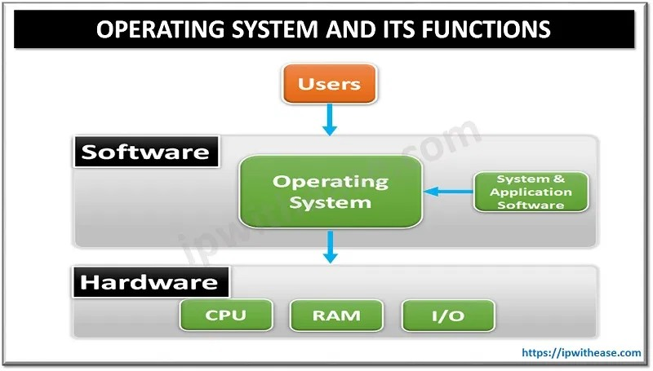

Some of the commonly used examples of operating systems are given below.

* Microsoft Windows
* Apple's iOS
* Apple's MacOS
* Android
* CentOS
* Linus
* Ubuntu
* Unix

# TYPES OF SOFTWARE:----

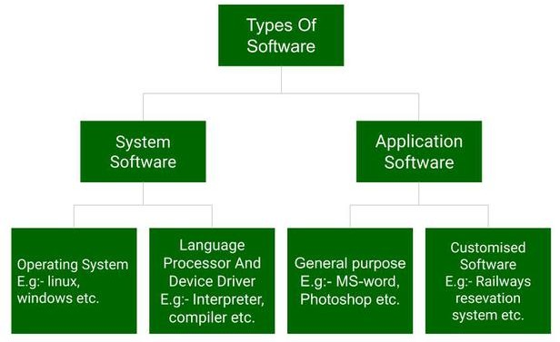

**WHAT IS SYSTEM SOFTWARE?**

If you think of software as being in layers, the system software is the bottom layer: it sits between the hardware and the application software.

Operating systems like Windows, macOS, Android and iOS are examples of system software. Operating systems are loaded into RAM when the device starts up, and have access to the hard drive.

# WHAT IS UTILITY SOFTWARE?

Utility software is part of the system software and performs specific tasks to keep the computer running. Utility software is always running in the background. Examples of utility software are security and optimisation programs.

Security programs include anti-virus software that scans and removes viruses. Most computers will include some sort of anti-virus software, but you can add your own.

Optimisation programs can include tools for system clean-up, disk defragmentation, and file

compression. These tools are typically installed as part of the operating system. They have access to the hard drive to keep it tidy.

# WHAT IS APPLICATION SOFTWARE?

This is everything else! Anything that is not an operating system or a utility is an application or app. So a word processor, spreadsheet, web browser, and graphics software are all examples of application software, and they can do many specific tasks.

You can remove and add applications on your computer using the operating system.

Application software like a word processor regularly directs the operating system to load and

save files from and to the hard drive. When you are working on a file, it is saved temporarily in the RAM. It is only when you choose to save it that it is written to the hard drive.

This is why, if the computer crashes while you’re working on a file, you may lose any changes you didn’t save. Data stored in the RAM is volatile. The data is lost when the RAM loses power.

# WHAT ARE DEVICE DRIVERS?

In computing, the device driver is a type of software that operates or controls some specific hardware devices linked to your system. They provide a software interface to hardware devices allowing computer operating systems and other applications to fetch hardware functions without knowing the exact specifications of the hardware.

Some common examples of such device drivers that connect hardware devices (printers, sound cards, network cards, hard disks, floppy disk, keyboard, mouse, etc.) to a system easily are as follows:

* BIOS (Basic Input/Output System) Device Driver
* USB (Universal Serial Bus) Drivers
* Motherboard Drivers
* Display Drivers
* Printer Drivers
* Sound Card Driver
* ROM (Read-only memory) Drivers
* VGA (Video Graphic Array) Drivers

# WHAT IS FIRMWARE?

In electronic systems and computing, firmware is a type of permanent software embedded in the system's ROM (read-only memory) to provide low-level control for some particular system device hardware. It is a set of instructions that are stored permanently on your computer's hardware device.

Common examples of devices utilizing firmware are given below:

* Computer Peripherals
* Consumer Appliances
* Embedded Systems
* UEFI (United Extensible Firmware Interface)
* BIOS (Basic Input/Output System)

# WHAT ARE WORD PROCESSORS?

Word processor applications are globally used for documentation, making notes, and typing data. It also helps the end-users store and format data. They also enable the users to print their documents.

Some examples of Word Processor software's are as follows:

* MS Word (Microsoft)
* iWork-Pages (Apple)
* Corel WordPerfect
* Google Docs

# WHAT ARE DATABASE SOFTWARE?

Database Software

Database software is used to create, manage, modify and organize a massive amount of data quickly retrieved. Another name for database software is Database Management System (DBMS). Such software helps companies in their data organization.

Common examples of Database Software's are:

* Oracle
* MS Access
* SQLite
* Microsoft SQL Server
* FileMaker
* dBase
* MariaDB
* MySQL

# WHAT IS MULTIMEDIA SOFTWARE?

This software enables the users to play, create or record images, music, and video files. Different graphic designing companies widely use multimedia software to make animation, images, posts, packaging, marketing creative, gif, or even video editing. Due to their popularity and increasing demand, every software product development corporation has massive avenues in creating and upgrading them.

Common examples of Database Software's are given below:

* Adobe Photoshop
* Windows Movie Maker
* Adobe Illustrator
* Picasa
* Windows Media Player
* Corel Draw

# WHAT IS A WEB BROWSER?

These are a type of software that is globally used to browse the Internet. Web browsers help the users in positioning as well as fetching data across the web.

Common examples of web browsers are given below:

* Chrome
* Mozilla Firefox
* Microsoft Internet Explorer
* Opera
* Microsoft Edge
* UC Browser
* Apple Safari

**WHAT IS FREEWARE?**

As the name suggests, Freeware software is available free of cost for an unlimited time. Any user can easily download their respective software from the Internet and start using them instantly

without paying any charges or fees. Software development companies mostly design and develop freeware software as a strategy to reach out to more people.

Typical examples of Freeware Software are as follows:

* Adobe Reader
* Zoom
* Skype
* ImgBurn
* Audacity
* Whatsapp
* Anydesk

**WHAT IS SHAREWARE?**

Shareware software is readily available on the Internet to download on a fixed trial basis. It is distributed freely with a set time limit, and at the end of the trial period, the user is asked either to pay the fee or uninstall the software. Some shareware, mainly including the gaming softwares, have a fixed trial based on the counts an application is opened rather than the number of days it has been installed on the system.

Give below are some of the popular examples for Shareware Software:

* Adobe Acrobat
* Adobe Photoshop
* AnyDVD
* PHP Debugger
* WinZip

WHAT IS OPEN-SOURCE SOFTWARE?

People usually get confused with freeware and open-source, but both are different. Though both the software are available on the Internet free of cost with the only difference that open source

software is available online along with their source code. It means the user can change, transform, and even can add additional features to them. Based on their services, they can be chargeable as well free of cost.

Give below are some of the popular examples for open-source Software:

* Mozilla Firefox
* MySQL
* Thunderbird
* OpenOffice
* ClamWinantivirus
* Apache Web Server

THANK YOU